# Quick Guide to Microsoft Power Automate (formerly Flow)

The purpose of this Quick Guide is to provide an introduction to Microsoft Power Automate. Power Automate is a powerful feature of Office 365 that automates tasks across Web services.

To see Microsoft Power Automate, go to <https://flow.microsoft.com> and sign in. When you sign in, you see something like this:

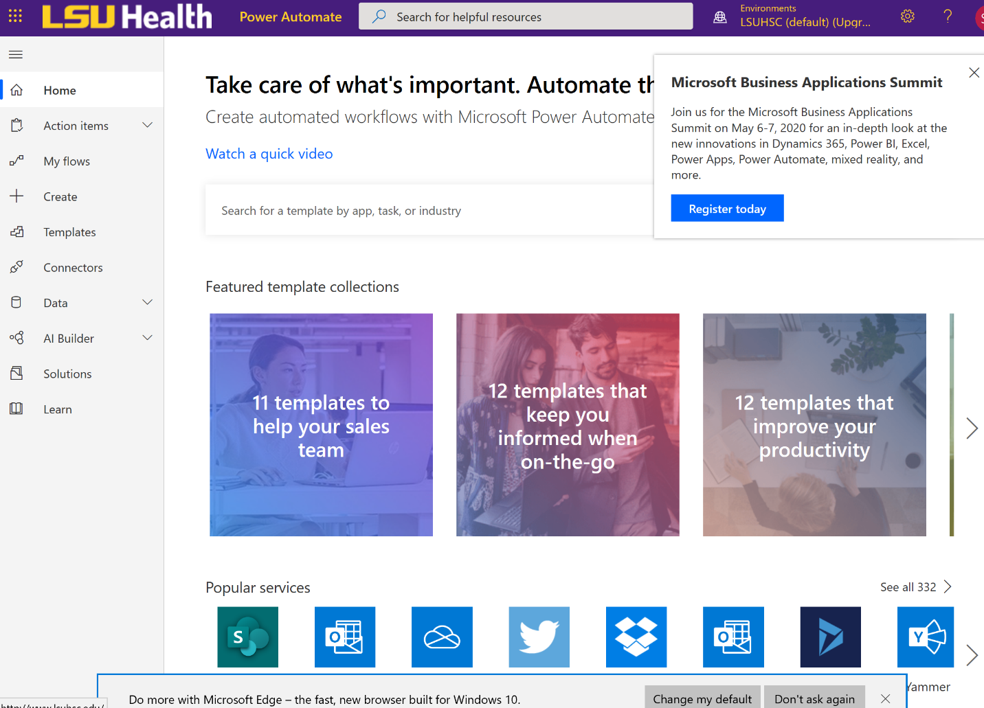

The basic item in Microsoft Power Automate is the *flow.* A flow consists of a *trigger* and a sequence of one or more *actions.* A flow can be created from the trigger alone or from a predefined template. Let’s do the latter. Click the “Templates” side menu item.

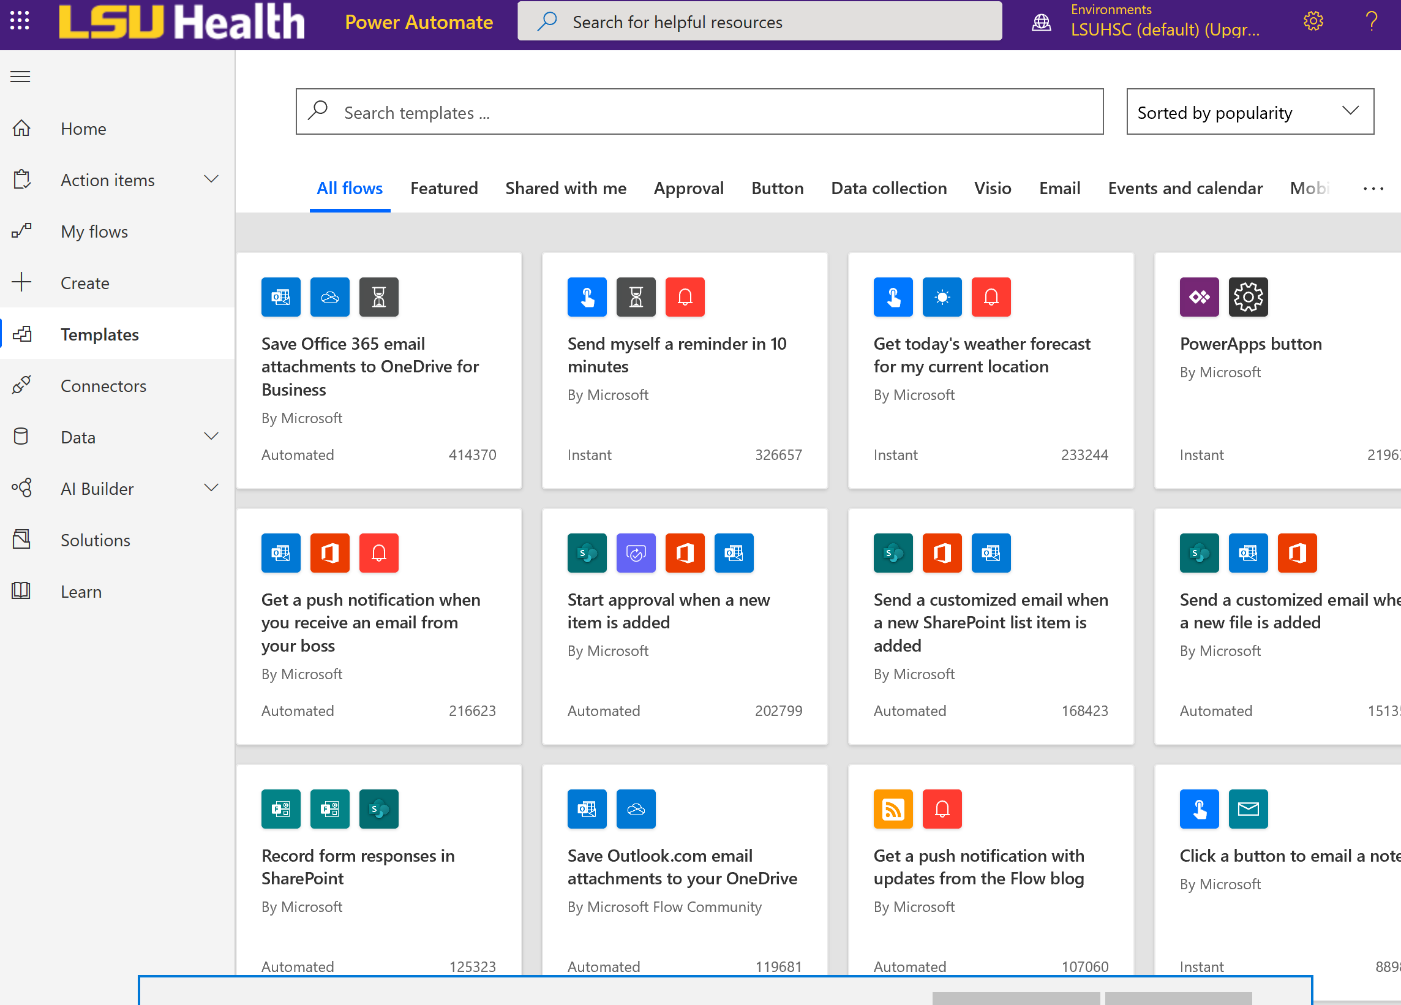  
Let’s find a template that sends an e-mail notification for completed responses. Type “when a form response is submitted” into the search bar and press Enter. Then select the following item:

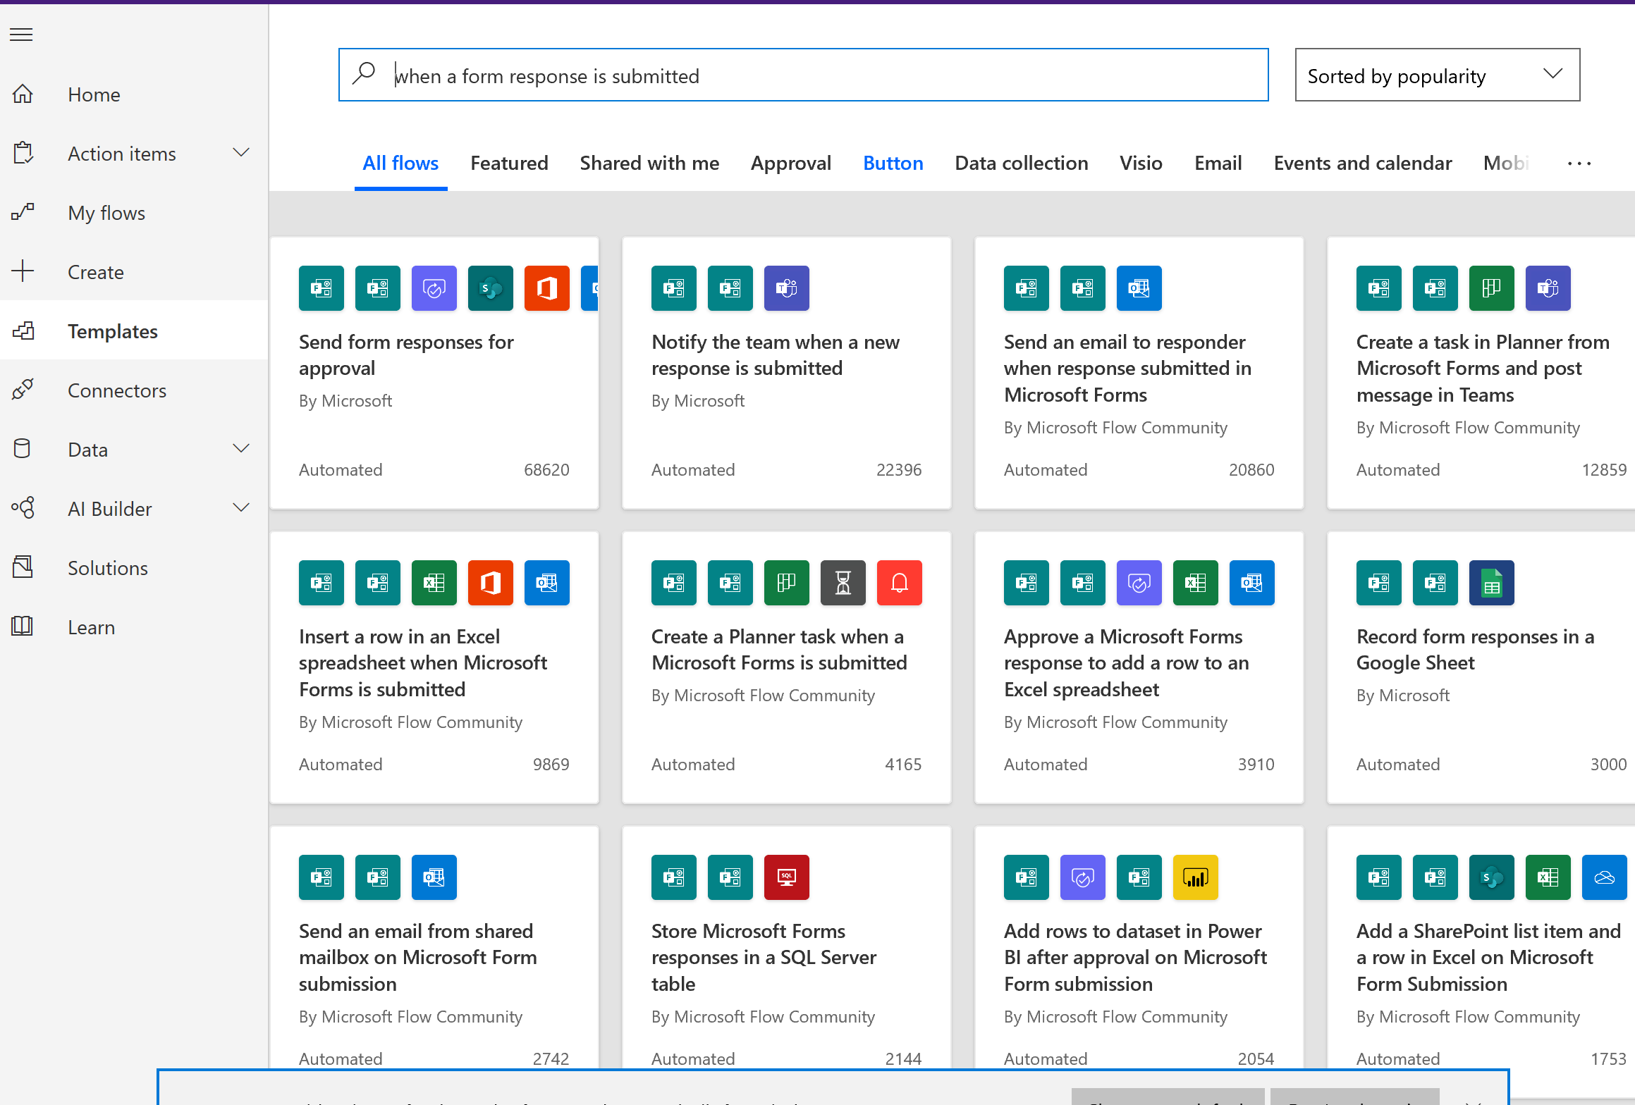

Click the “Continue” button.

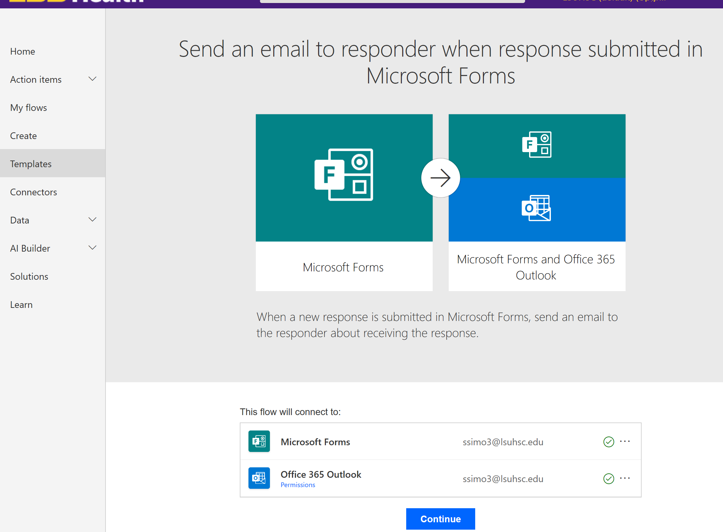

From here, we go to the Flow Editor. You can see that a trigger and three actions have been created. The trigger is “When a form response is submitted.” The first action is “Get form response.” This action gets the full data of the form response because it is not in the trigger body. The second action, “Condition,” evaluates a condition and executes one block of actions if the condition is true and another if the condition is false. The condition evaluates to true if the settings of the target form permit that “Only people in my organization can respond.” If users external to LSUHSC can respond, the form itself can record the e-mail in another field, and the flow can be updated accordingly. For the sake of this tutorial, we will assume that the form is internal to LSUHSC. While there is one action, “Send an email (V2),” under the “If yes” block of the condition action, the “If no” block is empty, so the condition simply returns, and the flow exits.

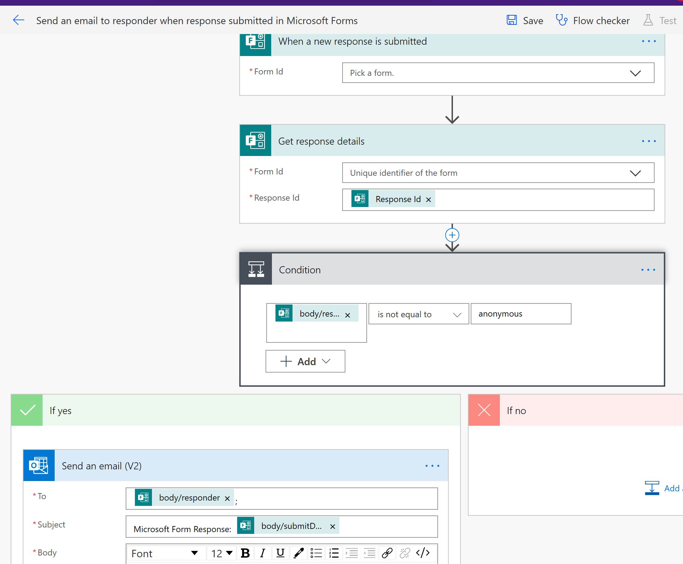

There are several basic things we need to do to get the flow to work. First, we can rename the flow. To do so, click on the test “Send an email to responder when response submitted in Microsoft Forms.”

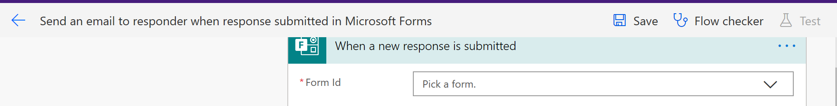

It might not be immediately obvious, but when you select this text, you can delete and type over it.

Next, we need to pick a form for the trigger.

Click the arrow to the right of “Pick a form.” The word “Loading” will show up. After it is finished loading, it will show a drop-down list of your forms. For the purposes of this example, I have selected a form entitled “Quick Guide.”

The SAME form should be used for the “Get Response” action.

C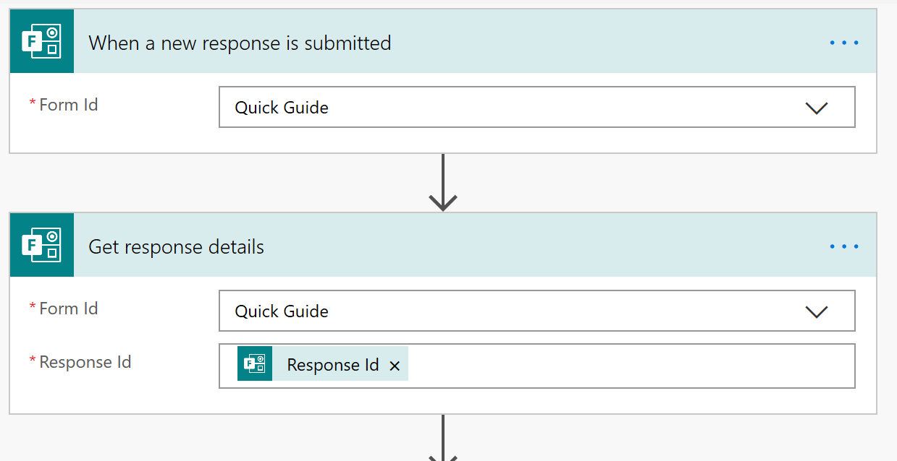

SAME FORM!!!!

# Testing the Flow

We are ready to test the flow. Saving the flow and testing is done by the toolbar to the right of the flow’s title.



First, save the flow. The Test button will become available when the saving has finished.

Click the Test button. Because this is the first time running our flow, we need to perform the trigger action. Select “I’ll perform the trigger action” and click the large blue Test button.

Submit the form in a *new browser tab* to see the flow results. You can click the Condition block to expand it and see that the e-mail was sent.

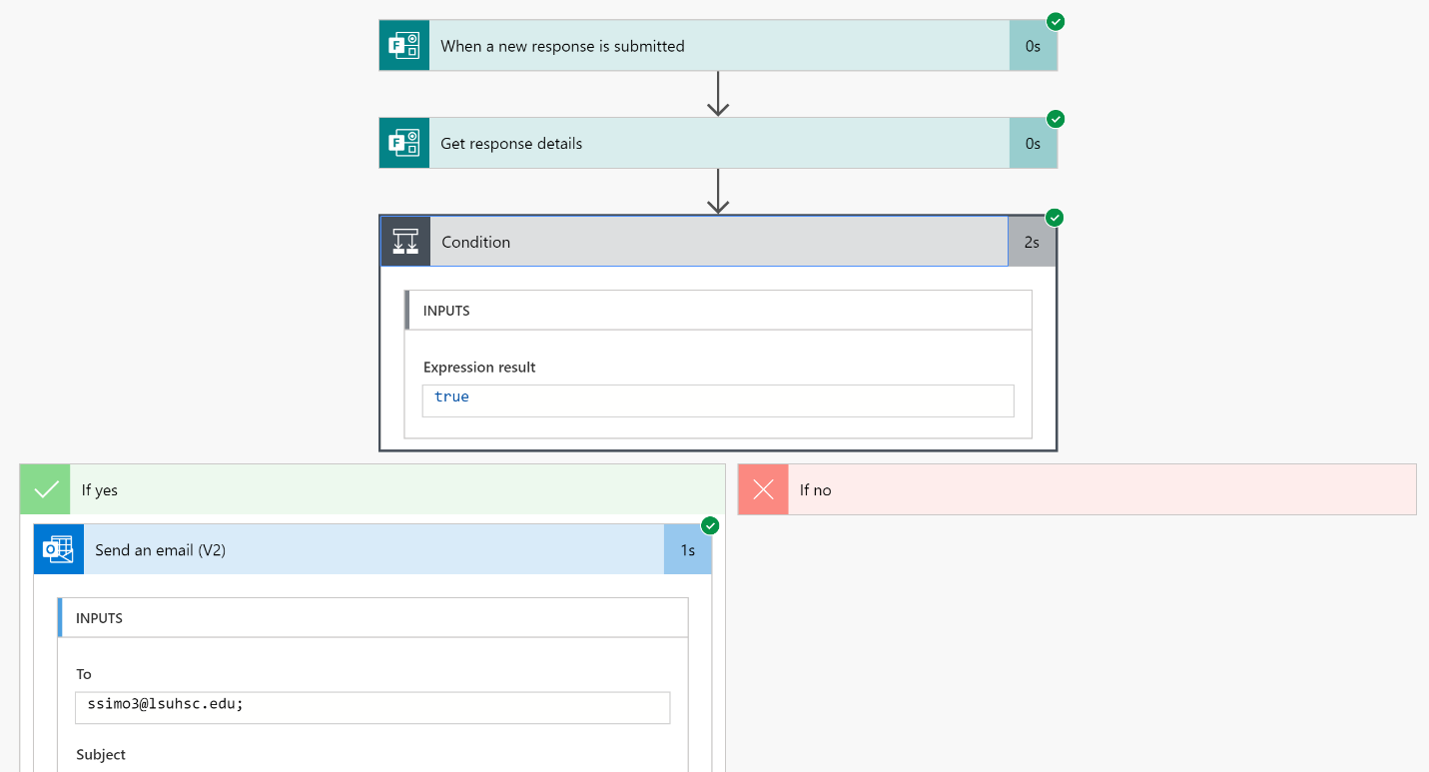

# Adding steps to the flow/Approvals

There is one common scenario that deserves to be covered in this Quick Guide. Sometimes we want somebody to intervene before an action proceeds. This is known as an *approval.*

To create an approval, we will add steps to our flow. To add a step to the *outermost* “block” of the flow, click the big “+ New Step” button at the bottom. However, we want to continue in the context of the “If yes” block.

Click the “Add an Action” link at the bottom of the “If yes” block. You should get something that looks like this:

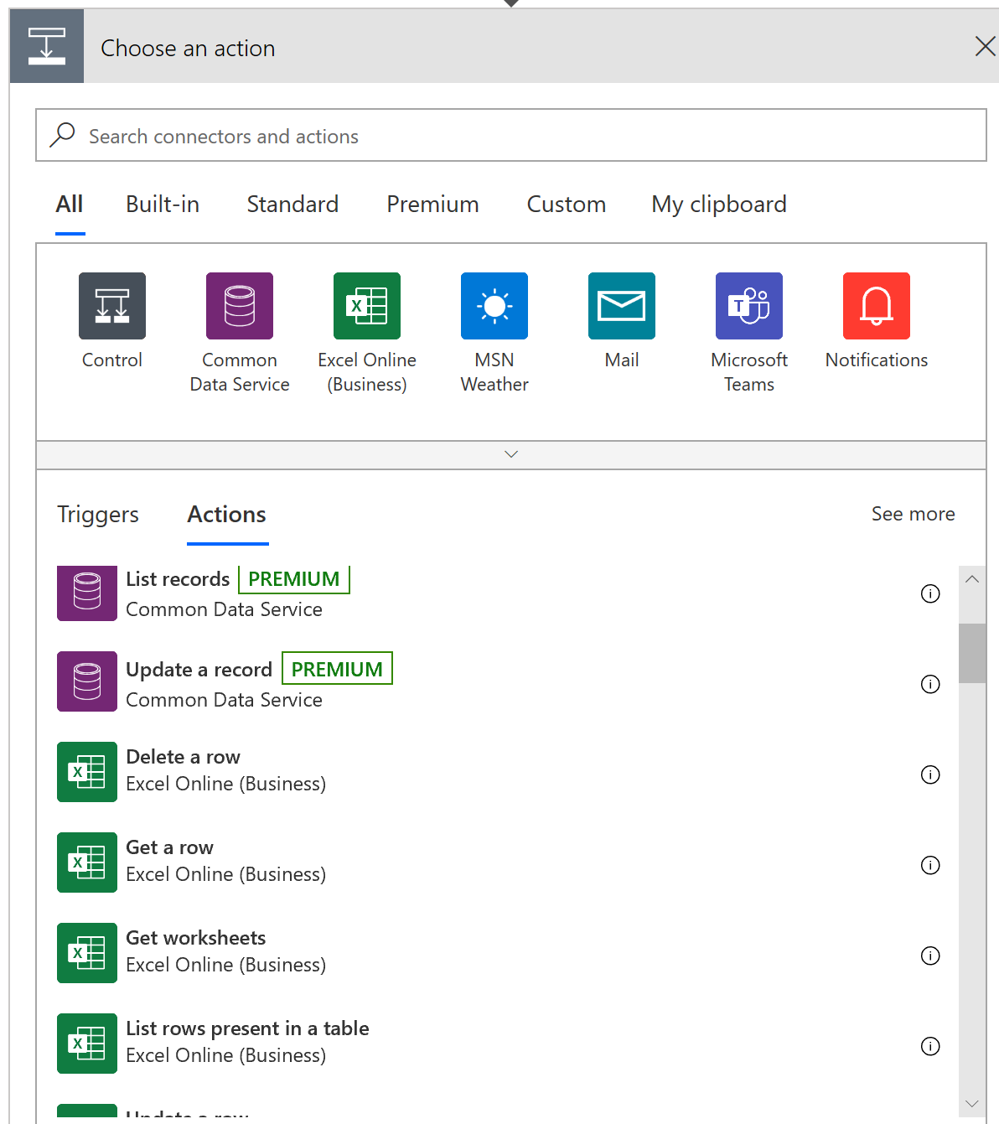

This is the Action Chooser. It shows a list of connectors and actions. You can optionally click on a connector to filter actions by that connector. Type “Start and wait for an approval” and click the first action that appears. When the action configuration block appears, select either of the two options that begins with “Approve/Reject” from the Approval Type dropdown.

It should be worth mentioning that the Title and Description fields can contain dynamic content from previous steps, and the approver will see the values substituted in. For example, Laura Stazio will see e-mail addresses and timestamps in place of the markers in the following configuration.

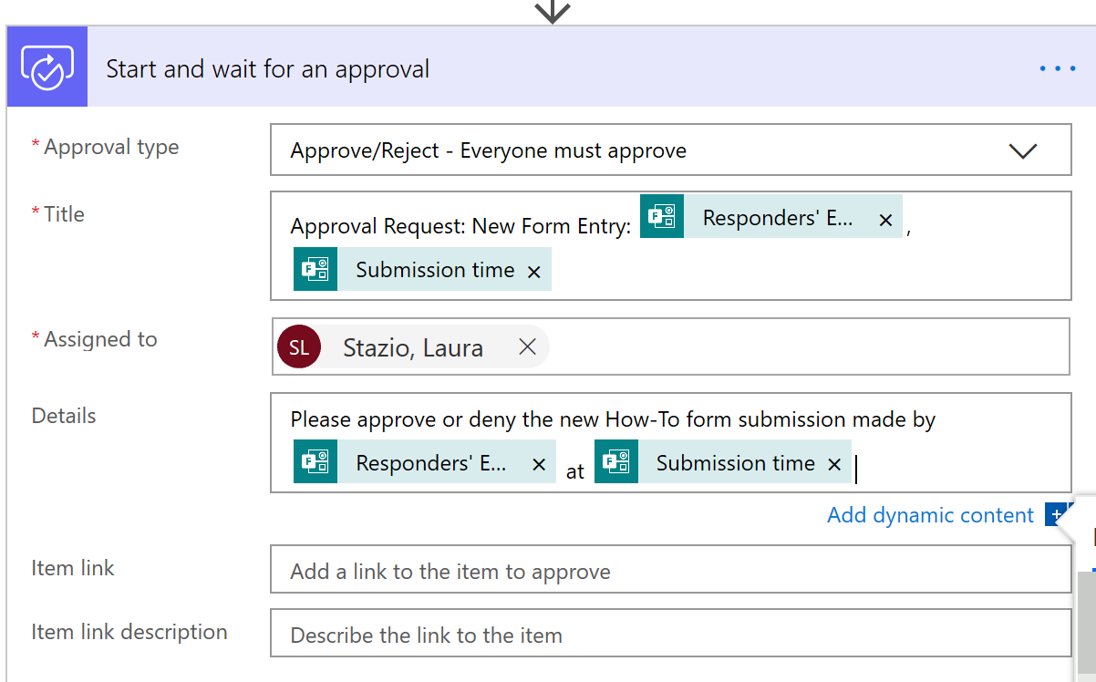  
Each person who is assigned an approval will see an e-mail message ***from Microsoft*** that looks something like this when using Outlook on a Windows desktop:

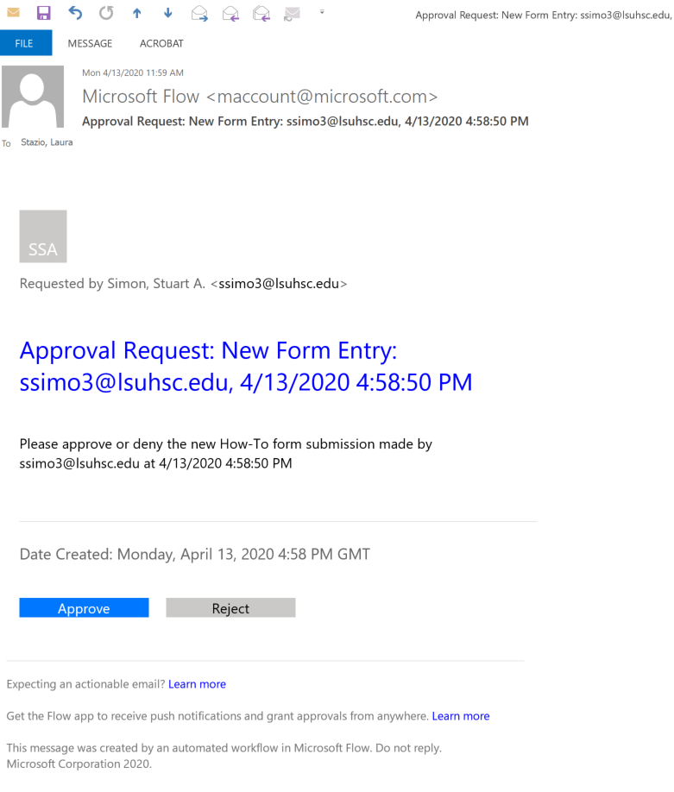An approval step in a flow is usually followed by another condition block. This “Condition” action was the first that showed up when I created the flow for this tutorial and the action chooser was in its default state. Again, the condition depends on dynamic content. In this case I selected “Reponses Response” in the dynamic content window. The condition was automatically wrapped in a loop. That’s OK because there is only a single approver, and so the loop will iterate only once. In the following example, I send different e-mail messages based on the approval response.

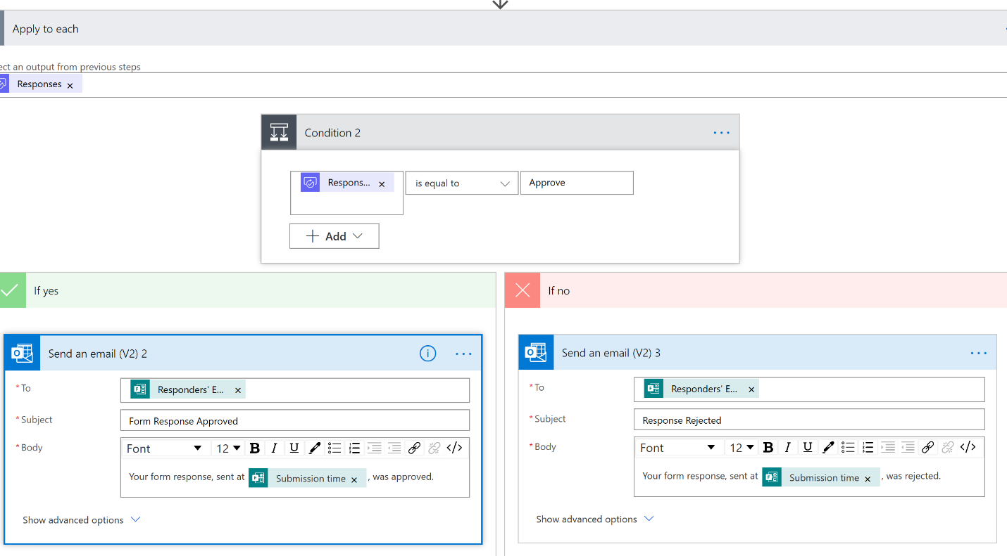

That is everything I want to go over in the Quick Guide for Microsoft Power Automate. It is way too versatile to handle all situations in one document.