Advocating for Individuals   
(and their Families) Living with

Fetal Alcohol Spectrum Disorders (FASD)

FRIDAY FEBRUARY 3, 2017  
8:00 AM – 4:45 PM

LOCATION: LSU Human Development Center, 411 S. Prieur St., New Orleans LA



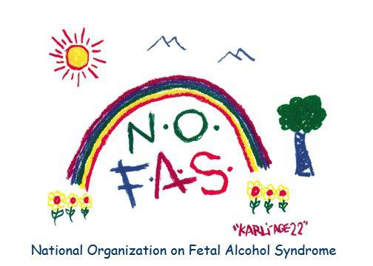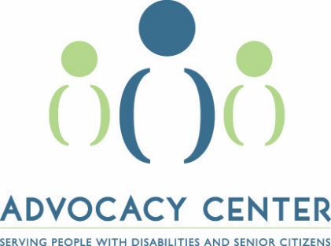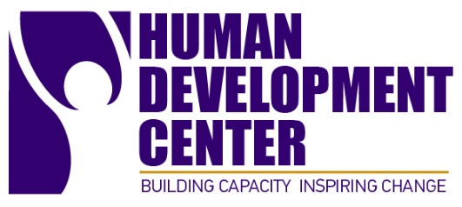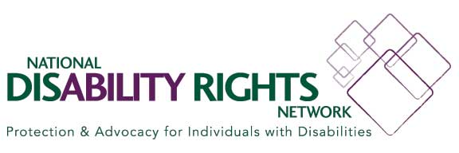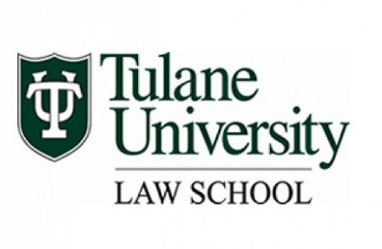

**Nationally Recognized Experts will be Featured.**

**Continuing Education Available for:**

**Attorneys, Educators, Nurses, Psychologists and Social Workers.**

Topics Include:

* Diagnosis & Treatment
* Early Childhood & Special Education
* Juvenile & Adult Criminal Justice
* Strategies & Interventions for Medical, Social Services & Mental Health
* Advocacy

Register at http://fasdconf.advocacyla.org/  
*For special accommodations and requests:*

*Contact Alisha Williams at awilliams@advocacyla.org*